**Deploying a Django Project on AWS EC2: A Step-by-Step Guide**

[[](https://medium.com/@awseng12?source=post_page---byline--787f646b5e77---------------------------------------)](https://medium.com/@awseng12?source=post_page---byline--787f646b5e77---------------------------------------)

[Shazab Tanveer](https://medium.com/@awseng12?source=post_page---byline--787f646b5e77---------------------------------------)

·

Following

2 min read

·

Jul 24, 2023

79

5



Are you ready to take your Django project live on an AWS EC2 instance? In this tutorial, we’ll walk you through the process of deploying your Django project on AWS EC2. So let’s get started!

**Step 1: Set Up AWS EC2 Instance and Open Port 8000**

To begin, make sure you have a t2.micro instance on AWS and open port 8000 in the security group. We’ll be using an Ubuntu machine for this demonstration.

**Step 2: SSH into the Instance and Install Django**

SSH into your AWS EC2 instance and update it using the following command:

apt-get update

Next, clone your Django project repository onto the instance using git:

git clone https://github.com/yeshwanthlm/django-on-ec2.git

**Step 3: Install Django and Prepare the Database**

Install Django on your AWS EC2 instance with the following commands:

sudo apt install python3-pip -y  
pip install django

Once Django is installed, navigate to the cloned repository directory and run the following commands to set up the database migrations:

python3 manage.py makemigrations  
python3 manage.py migrate

**Step 4: Create an Admin User**

To manage your Django app, create an admin user by running the following command in the terminal:

python3 manage.py createsuperuser

Provide a username, password, and email for the admin user when prompted.

**Step 5: Host the App**

Finally, it’s time to make your Django app live! Start the server using this command:

python3 manage.py runserver

Your app is now hosted on the AWS EC2 instance! Visit <http://instance_ip:8000/todos> to access your simple todo app and start managing your tasks.

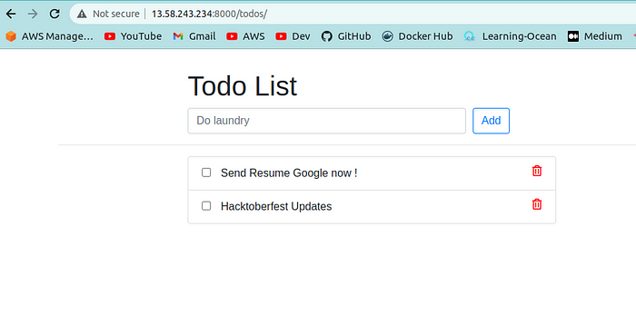

Congratulations! You’ve successfully deployed your Django project on AWS EC2. Feel free to explore more AWS features to scale and secure your app for production use. Happy coding!

Youtube: <https://www.youtube.com/watch?v=uiPSnrE6uWE>

Linkedin: [**www.linkedin.com/in/shazabtanveer**](http://www.linkedin.com/in/shazabtanveer)